TASK 7 – Control Type Conversion and Precision
7.1 Type conversion
Type conversion occurs when the program combines values of different types. For example, multiplying an int unit count by a long long rate can cause the integer value to be converted to long long before the multiplication.
For the billing program, money is stored in integer paise to avoid rounding errors. When displaying the bill, division by 100 produces the rupee part, and the remainder produces the paise part.
7.2 Three examples of unexpected results
Example 1: Integer division
Output:
Example 2: Floating-point precision

Output:

Example 3: Casting a large integer to int
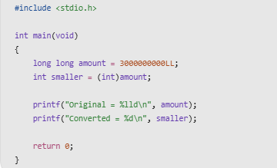
The original value is larger than the maximum value of a typical 32-bit int. The conversion result is implementation-defined or otherwise governed by the applicable C standard rules when the value is not representable. Do not rely on the converted value being correct.
7.3 Rounding rule
If a tariff produces fractional paise, define a consistent rounding rule before storing the result. For example, a fractional paise amount can be rounded to the nearest paise. If the tariff is expressed as a whole number of paise per unit, integer multiplication avoids this issue.
7.4 Alternative concept and complexity analysis
Using float rupees makes calculations convenient but can introduce small representation errors. If each bill has an error of approximately \(\epsilon\), the accumulated error across \(n\) bills may grow roughly with \(n\epsilon\) in a worst-case same-direction accumulation, although actual floating-point error depends on the values and order of operations.
Both integer and floating-point addition are generally \(O(1)\) time per operation. Integer paise uses a fixed amount of storage and gives exact results while values stay within range. Floating-point values also use fixed storage, but not every decimal amount is represented exactly.
Conclusion: Integer paise is the preferred method for this tariff because it produces predictable, exact monetary totals.
This expands macros and processes header files and conditional compilation.

